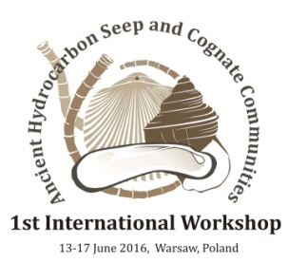
Registration form for 1st International Workshop on Ancient Hydrocarbon Seep and Cognate Communities.

13-17 June 2016, Warsaw, Poland

Salutation: Click and choose
Name (first, m., last):
Affiliation:
Address:
Email:
Phone:
I would like to participate as: Click and choose
Preliminary title:
Workshop dinner (fee 20 Euro): Click and choose (Vegetarian: Click and choose)
Excursion: Click and choose
Free guest room (attach application): Click and choose
Paid guest room: Click and choose

